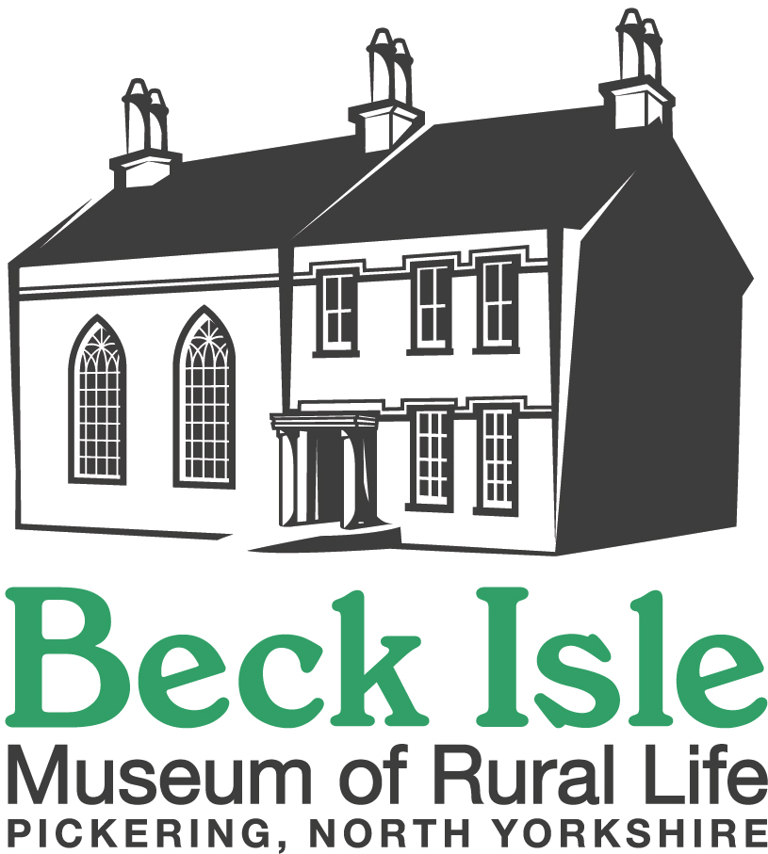 GROUP BOOKING FORM

It is essential that you contact us to confirm your required date is available

Name of Organisation or Group:……………………………………………………………………………….
Contact Name: …………………..………………………………………………………………………………
Address: ………………………………………………………………………………………………………….
……………………..……………………….. …………………………………….………………………………
Telephone: …………...……..……..…………. Email: ……………………………………………………….

Visit Date: ………………………………………………………………………….

Number of Adults: …………………
Number of Children:……………………………..…………Ages: …….………………………….

Arrival time: ………….……………………………… Departure time: ………………………………….…..
Special needs or requirements: …………………………………………………………………………………

Organiser’s signature:…………………………………..……………… Date: ……………………………
Please allow approximately 2 hours for your visit. Please inform us if you are running late on your visit day.
Cost: Adults £5 per head. Children £3 per head (cheque/cash on day of visit only)

