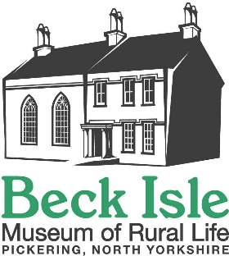
Beck Isle Museum - Volunteer Application form

Thank you for your enquiry about volunteering at Beck Isle Museum.

Date of Application

Title: Name:

Address

Postcode Email

Telephone (home) Mobile

There are a number of different volunteer roles. Please indicate which role(s) you may be interested in. Full induction and training will be provided for all roles.

Desk Steward |  | Room custodian
Practical helper (e.g. painting, cleaning, etc) |  | Garden assistant
Agricultural heritage / restoration |  | Activity / event volunteer
Education / outreach |  | Historical researcher
Design / photography / printing |  | Administration / finance
Other skills / knowledge (please state)

We recognize that your availability may vary, but it would help if you could indicate your usual availability (please tick)

Monday |  | Tuesday |  | Wednesday |  | Thursday |  | Friday |  | Saturday |  | Sunday
am | pm | am | pm | am | pm | am | pm | am | pm | am | pm | am | pm

Please tell us a little bit about yourself, including why you are interested in volunteering at Beck Isle Museum.

Please tell us about any previous experience that you think would be useful in this volunteer role – this could be experience as a volunteer or paid employment.

How did you hear about volunteering at Beck Isle Museum?

Please supply the names of two referees. Referees should have known you for a period of 3 years or more and should not be related to you.

Referee 1 – Name:

Address:

Email:

Tel No:

Referee 2 – Name:

Address:

Email
Tel. No.

Do you have any criminal convictions that are not ‘spent’? Yes No
If ‘Yes’, please give details on an additional sheet of paper.

If you are accepted as a volunteer you will be asked to provide proof or identity (passport, driving licence or bus pass) as well as proof of residence (council tax or utility bill).
Data Protection Act 1998 and 2018. Beck Isle Museum will only use the information provided by you to assess your suitability to volunteer with us and to support you in your volunteering role. This information will be removed from our database when you notify us that you no longer wish to volunteer. We reserve the right to gather information from other sources too, for example, by using your references.
Please return this form to:
The Museum Manager, Beck Isle Museum, Beck Isle, Pickering, YO18 8DU

Tel: 01751 473653 opsmanager@beckislemuseum.org.uk

