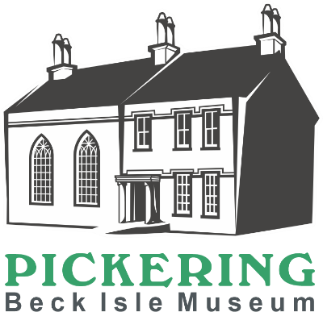
Collections Care Volunteer
We are looking for a couple of volunteers to join our Collections team with specific responsibilities to care for the objects on display.
Main Duties
- Clean objects in appropriate manner to get rid of surface dust and grime.
- Vacuum and dust the open room display areas.
- Monitor for pest activity – alert Collections Manager to any worrying signs.
- Assist Collections Manager with organising winter cleaning priorities.
- Dust objects in cases and clean glass fronts.
- Explain to the visitors what you are doing, while cleaning the objects in a gallery.
- Adhere to the Museum’s Health and Safety Policy
How much time will I be expected to give?
This is a new role so it may be subject to change but one three hour session a week minimum. However a number of volunteers can share the Collections Care role and for some tasks it may be helpful to work in pairs and more enjoyable to be able to talk to someone while working.
What skills, qualities and experience do I need?
- An interest in cleaning objects
- A gentle and methodical approach to caring for the collection
- Good verbal communication skills
- An interest in heritage and local history
- Enjoy working as part of a team
- Willingness to undertake relevant training
- Commitment to excellent customer service
- Commitment to equality and diversity
- Physically able to use the equipment needed to assist with the job, i.e. step ladders, a museum vacuum cleaner, a folding table and chairs,
- Physically able to move museum objects with care and control, (help will be available for larger/heavier items

What support and training will I receive?
You will receive a Collections Care training session which includes a tour of the museum, explanation of the role, how to use equipment and where it is stored. Online training in the form of two videos made by a conservation department on how to surface clean museum objects will be emailed to you before the training at the museum. Further training, support and supervision will be provided by the Collections Manager.
What can I expect from the museum?
- To become part of a motivated and enthusiastic team
- To learn about the museum and local history
- To meet new people within your local community
- To learn new skills
- A 10% discount in the museum shop
- A rest room with tea and coffee provided
- We are members of the Volunteer Pink Pass. After three months volunteering you will receive a pink pass which entitles you to free and discounted entry to hundreds of museums across the North of England
- Free carparking whilst carrying out volunteering duties (subject to availability)

Other Information
- The role is open to volunteers aged 18+
- This role is not regulated activity and therefore does not require an additional safeguarding (DBS) check
Please complete the application form which can be found on our website www.beckislemuseum.org.uk or contact Michala Pearson (Engagement and Operations Manager) for an informal chat 01751 473653 opsmanager@beckislemuseum.org.uk
or Sarah Maultby (Collections Manager) manager@beckislemuseum,org.uk

