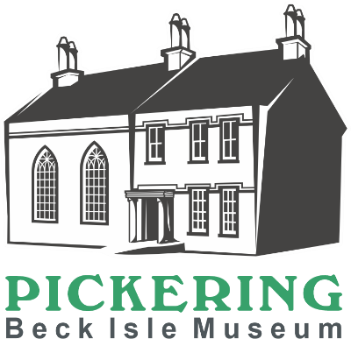
Front of House Volunteer
We are looking for volunteers who would like to join our enthusiastic and friendly front of house team.

Main Duties
- Creating a warm and friendly welcome for all our visitors, answering general enquiries and ensuring that visitors have an enjoyable visit
- Selling tickets and items from the shop using a till system
- Carrying out visitor surveys
- Gentle cleaning as needed to provide a high standard of presentation
- Regular walks around the museum to check on exhibition spaces
- Ensuring that the museums health and safety procedures are followed and, in an emergency carrying out the evacuation procedure

How much time will I be expected to give?
The museum is open Monday to Saturday. You can choose to volunteer in a morning (9.45-1.30pm) or an afternoon (1.20-5pm). Volunteering hours vary depending on the time you have available. As a guide we would expect a minimum of two sessions a month. You can choose a regular time slot or can vary it to fit with your other commitments.

What skills, qualities and experience do I need?
- Commitment to excellent customer service
- Good verbal communication skills
- An interest in heritage and local history
- Ability to handle money
- Enjoy working as part of a team
- Willingness to undertake relevant training
- Commitment to equality and diversity

What support and training will I receive?
You will receive a welcome training session which includes a tour of the museum, till training and will familiarise you with the front of house role. Whilst on the front desk you will be supported by an experienced volunteer. Further training, support and supervision will be provided by the Engagement and Operations Manager.
What can I expect from the museum?
- To become part of a motivated and enthusiastic team
- To learn about the museum and local history
- To meet new people within your local community
- To learn new skills
- A 10% discount in the museum shop
- A rest room with tea and coffee provided
- We are members of the Volunteer Pink Pass. After three months volunteering you will receive a pink pass which entitles you to free and discounted entry to hundreds of museums across the North of England
- Free carparking whilst carrying out volunteering duties (subject to availability)

Other Information
- The role is open to volunteers aged 18+
- This role is not regulated activity and therefore does not require an additional safeguarding (DBS) check
Please complete the application form which can be found on our website www.beckislemuseum.org.uk or contact Michala Pearson (Engagement and Operations Manager) for an informal chat 01751 473653 opsmanager@beckislemuseum.org.uk

